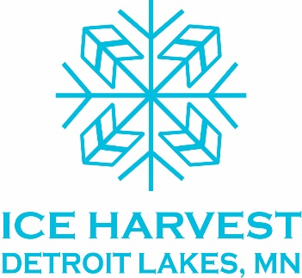 presents 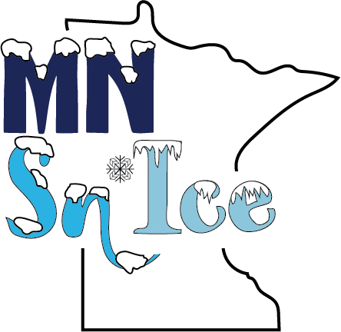

Sponsorship Opportunities for Restaurants/Bars & Retail

The Ice Harvest DL committee introduces you to MN Sn’Ice: A Snow & Ice Showcase. We have been dreaming up ideas for 2019, 2020 and 2021!

We know that the Ice Palace in 2018 brought a great number of people to DL, and many of those individuals shopped, dined or enjoyed refreshments in area establishments. We hope that your business saw a burst of activity in February 2018.

We would like to continue that winter energy and we would appreciate your support! Here is your opportunity to support the continuation of snow and ice creations in the DL City Park and City Beach area. For 2019 and 2020, we plan to create incredible snow and ice sculptures with local artists and professional ice carving teams. In 2021, we will once again do a large ice harvest and build another spectacular ice palace.

Snowcone Sponsor
Three year commitment of $1500 ($500 each year for three years)

- Business Name on the Sponsor Post near park/beach
- Name a on website as a Snowcone Sponsor and social media (as possible)
- Sponsor acknowledgement in printed brochures

We have asked area businesses to support at the $2500 and up level, but this Snowcone/$1500 level is just for restaurant and retail establishments. In Kind contributions are welcome and needed at all levels!

Thank you for your consideration in support of this exciting event!
Follow online at www.iceharvestdl.org
and on Facebook, Instagram, Twitter @IceHarvestDL

About the Ice Harvest DL Committee

- In 2017, a group of people came together to build an ice palace in Detroit Lakes and re-create ice harvesting, a long ago tradition in our region. We harvested over 1 million pounds of ice in January 2018 and built a three-story ice palace which was on display during Polar Fest 2018.
- The DL Ice Palace Committee fell in love with snow and ice sculptures and the whole process of creating winter magic. We decided to continue to offer this to our community with MN Sn’Ice: A Snow & Ice Showcase.
- The Becker County Historical Society acts as our fiscal agent. Donations/sponsorships to our snow/ice projects may be eligible as a tax deduction. Check made payable to BCHS-Ice
- Members of the MN Sn’Ice Steering Committee include: Lance Akers, Emily Buermann, Scott Busker, Susan Busker, Jed Erickson, Amy Erickson, Helen Foltz, Ken Foltz, Hans Gilsdorf, Carrie Johnston, Becky Mitchell, Jennifer Ovsak, Eric Rotter, Amy Stearns, Scott Walz, Tiffiny Walz, Brian Mann
- Polar Fest 2019 Dates: February 8 - 18, 2019.

