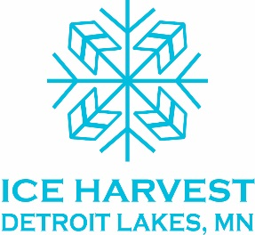 presents 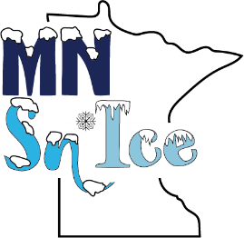
Sponsorship Pledge Card

Count me in! I’d like to support the Ice Harvest DL group and the MN Sn’Ice plan at the following level with payments due in December 2018, September 2019 and July 2020:

______ $15,000 – Three Year Royal Sponsor ($2500, $2500 and $10,000)

______ $10,000 – Three Year Palace Sponsor ($1500, $1500 and $7000)

______ $5,000 – Three Year Iceberg Sponsor ($1000, $1000 and $3000)

______ $2,500 – Three Year Ice Block Sponsor ($500, $500 and $1500)

______ $1,500 - Three Year Snow Cone Sponsor ($500, $500, and $500)

______ Three Year In-Kind Sponsor at an anticipated dollar level of _________

______ One Time Sponsorship in the amount of _________________

I agree to the above billing cycle per sponsorship level or I’d prefer to be billed in increments of ______________ annually. Quarterly or monthly billing available on request.

Name or Business___________________________________________________________________
Contact Person_____________________________________________________________________
Phone #___________________________________________________________________________
Email_____________________________________________________________________________
Address ___________________________________________________________________________
__________________________________________________________________________________
Please make checks payable to: Ice Harvest DL, c/o Becker County Historical Society, 714 Summit Ave., Detroit Lakes, MN 56501
THANK YOU!!

